**Name:Attay Rasool**

**Roll no:p180046**

**Section B**

**Subject : Computer Network Lab**

**Lab :01**

**Ipconfig:**

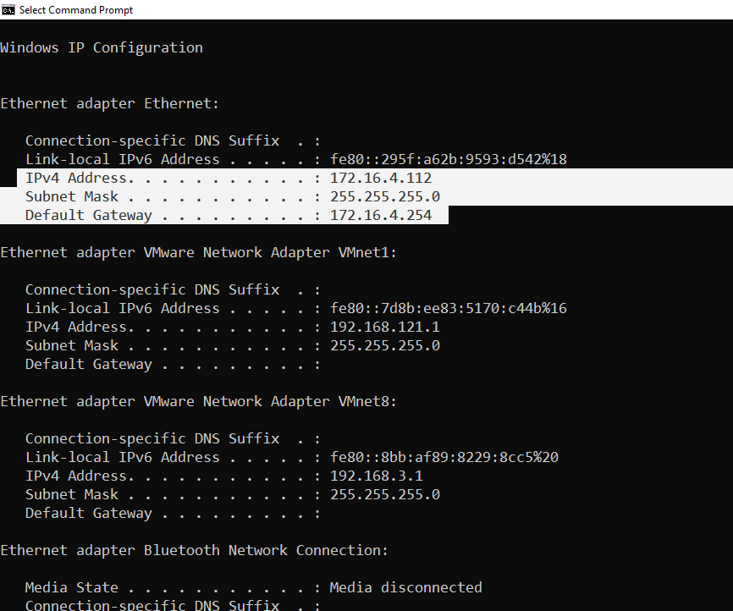

**Ethernet adapter Ethernet:**

a. IPv4 Address: 172.16.4.112

b. Subnet Mask : 255.255.255.0

c. Default Gateway : 172.16.4.254

**Task2:**

Host1: 171.17.1.110

Host2.172.16.1.101

Host3.172.17.1.210



**Task3:**

**a):**

We can find Ip address using windows powershell with the help of **gip** command

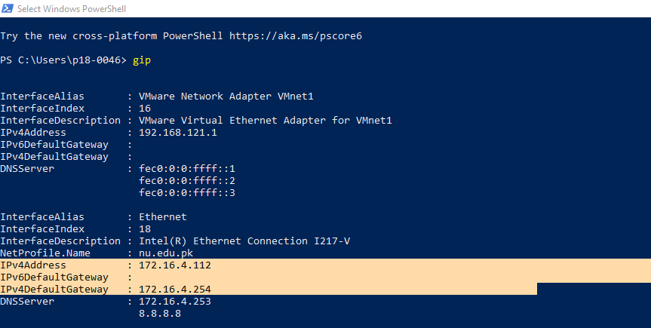



b):we can check our ip address by our computer setting.

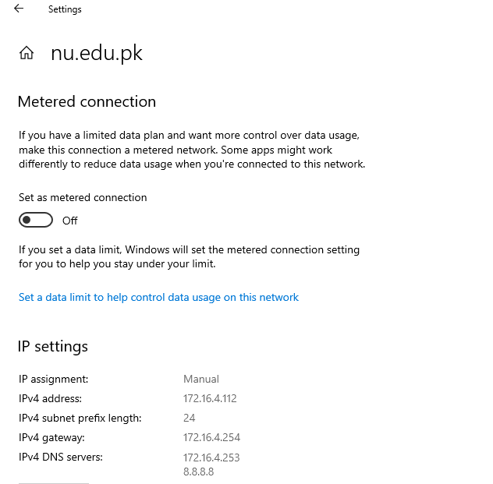



c):

check your Ethernet status to get your ip address.

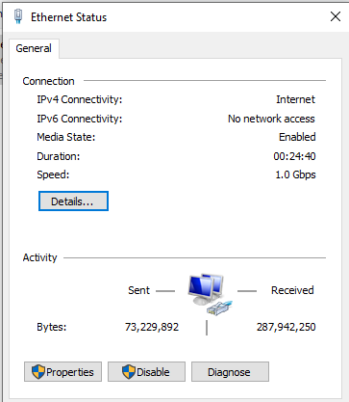

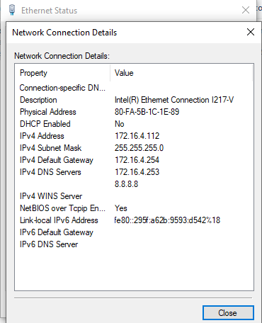



d):

Type **Get-NetIPConfiguration** on **powershell:**

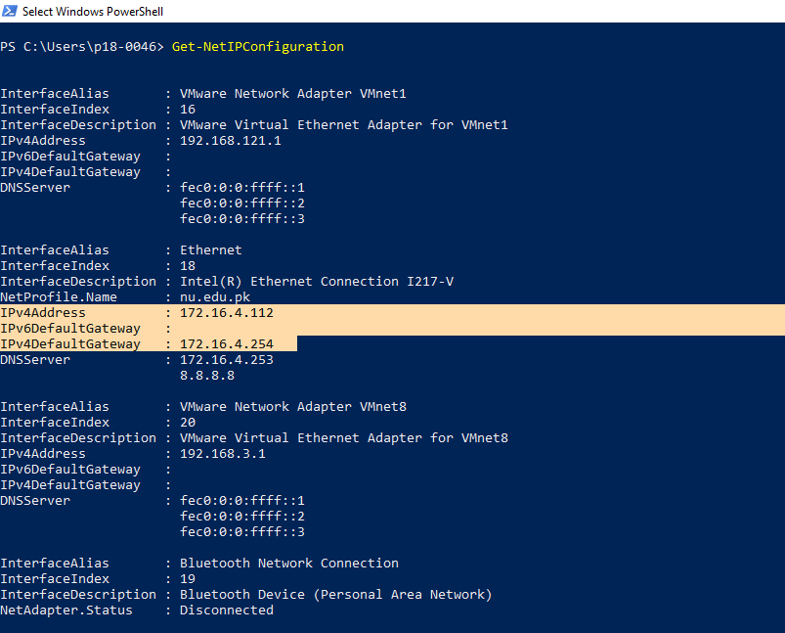

e):

In Task Manager we can check our ip addresses.

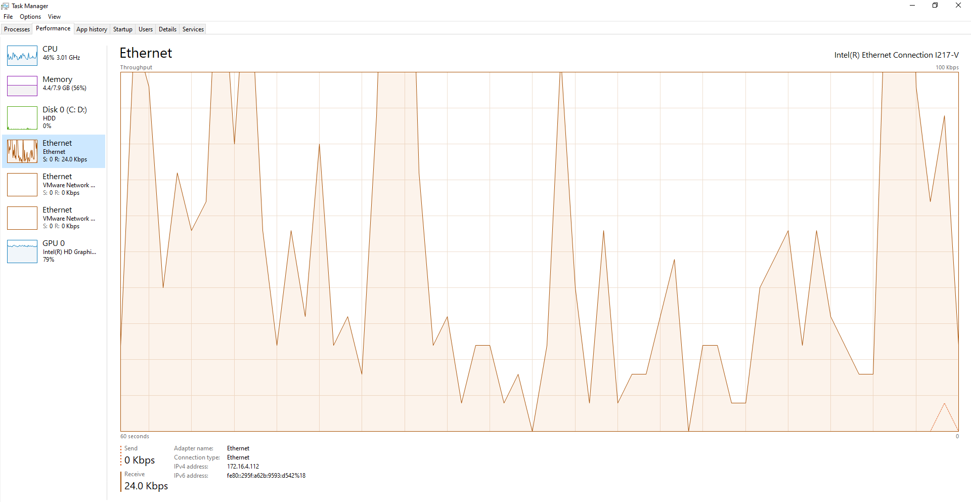



f):we can get ip address by system information.



